# Urbanite Chunky Sneakers

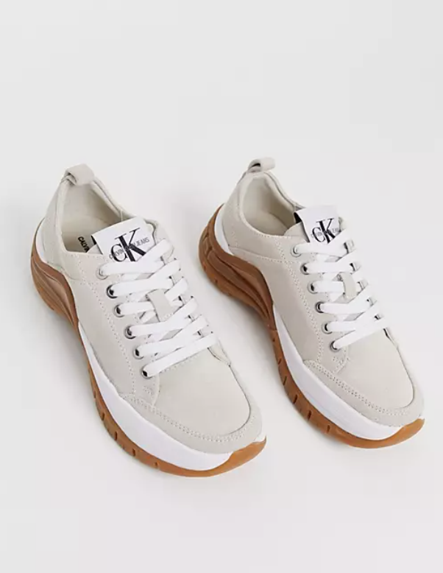 Product Details:

Color Combination: The CK Urbanite Chunky Sneakers showcase a sophisticated blend of colors including rich brown, warm grey, and soft beige.

Material: Crafted from premium synthetic leather and durable textile materials, ensuring both style and longevity.

Sole: Featuring a chunky rubber sole with a contrasting color to add an edgy touch to your ensemble.

Closure: Lace-up closure system for a secure and adjustable fit.

Branding: Embossed CK logo detailing on the tongue and subtly on the side for a branded finish.

Comfort: Padded collar and cushioned insole offer exceptional comfort and support, making them ideal for all-day wear.

Style: These sneakers effortlessly blend urban chic with contemporary design, making them a versatile addition to any wardrobe.

Occasion: Perfect for casual outings, urban adventures, or adding a stylish flair to everyday wear.

Versatility: Pair with jeans, joggers, or even a casual dress for an effortlessly cool look that exudes confidence and style.